Working with lists
fILL uses interactive data tables to present interlibrary loan information to you. These data tables enable you to sort and search through the data quickly and easily, save the data to your own computer, or format it for printing. Here's how:

Example data table
This example is taken from the Lending to other libraries => Respond section; other data tables will present different fields and actions that you can perform on a row (such as marking a requested item as sent (or unfilled) in this example).
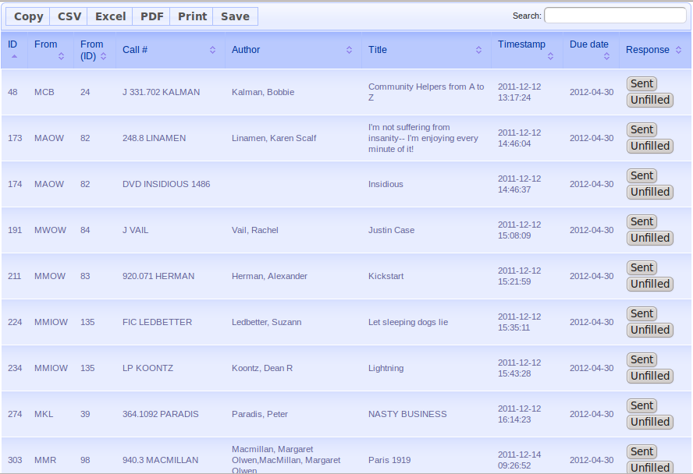

“Disappearing” rows
A quick note about the action buttons (usually in the right-most column): As you take actions, the rows may disappear from the table.
This is normal.
In the above example, if you click the Sent button for the title “Lightning”, that request now has a status of “Shipped”, and is removed from the table of requests that are waiting for your response.

You will always be able to find the request in the Current ILLs section (or History, after it's life cycle is complete), regardless of it's status.

Sorting the data
You can sort a data table by clicking on the column heading for a column.
The example data table is sorted by timestamp. To sort by Author, click the word “Author” in the heading:
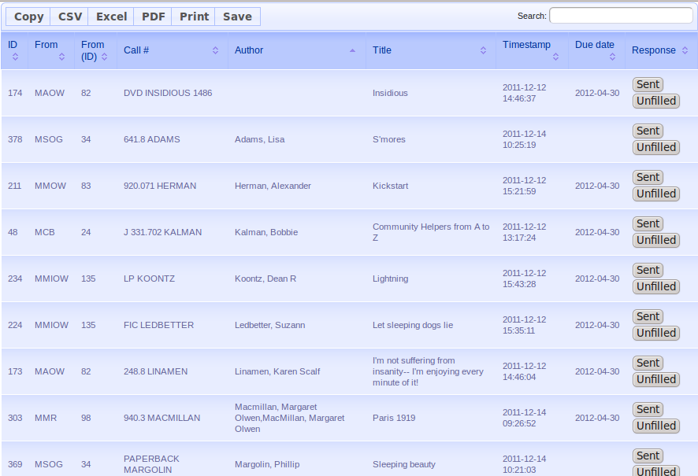
- Clicking it again will reverse the sort (in this case, reverse alphabetical order).
- You can sort by any column (some will make more sense than others), as often as you want.
- One current limitation is that you cannot sort by multiple columns at once.
- Sorting is very fast – the data table already has all of the data, and does not need to talk to the fILL server each time.

Searching within the data
The search box, in the upper right corner of the data table, is fast and powerful. It enables you to do a keyword search across all of the data in the table, and display only those rows that match.
For example, if you wanted to see which requests are from South Central Regional's Miami branch (MMIOW), just enter 'mmiow' in the search box:
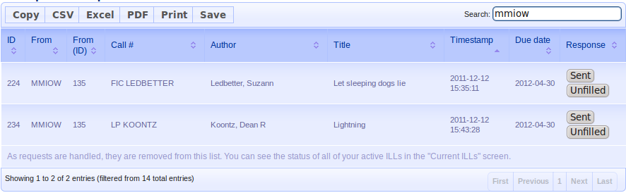
- The data table begins filtering as soon as you begin typing.
- Searching is not case sensitive (e.g. Searching for 'mmiow' will also match 'MMIOW')
- To get back to the complete table, just delete the text you've entered in the search box.
- Searching is very fast – the data table already has all of the data, and does not need to talk to the fILL server each time.
- You can combine searching and sorting. For example, if you typically handle ILL requests library-by-library, you could use 'search' to display the requests from a specific library, and then sort in call # order to make it easy to pull books from the shelves.
Some experimentation should let you figure out what works best with your workflows.

You can keep copies of the data locally... if you really want to
In the upper left corner of the data table is a set of buttons that enable you copy, save, and print the entire contents of the data table, if that suits your workflow.
- Copy: lets you paste the data into a document
- CSV: save the data as a comma-separated-value text file.
- Excel: save the data in Excel format.
- PDF: saves the data as a PDF (Adobe Acrobat) file
- Print: formats the data table for printing. Use the browser's print function to print it. Press ESC (escape) to return to the current view. (Note that while in the formatted-for-printing view, you can still sort by column, etc.)
fILL should handle all of the ILL tracking, statistics gathering work that makes up the bulk of the “ILL overhead” in terms of staff time. If you keep copies of the data locally for some ILL-management reason that fILL doesn't handle, let us know – if it makes ILL workflows easier for all libraries, we'll see about adding that functionality directly in fILL.

